**Ideation Phase**

**Brainstorm & Idea Prioritization**

|  |  |
| --- | --- |
| Date | 12 April 2025 |
| Team ID | SWTID1742751842 |
| Project Name | ShopEZ: One-Stop Shop for Online Purchases |
| Maximum Marks | 4 Marks |

**Brainstorm & Idea Prioritization**

The initial phase of the ShopEZ project involved extensive brainstorming sessions to identify features that would create a smooth and impactful e-commerce experience. Our team explored user needs and technical feasibility to generate a list of potential functionalities.

This structured approach ensured that development efforts were aligned with both user expectations and project deadlines, allowing us to build a functional MVP (Minimum Viable Product) quickly, while planning for future scalability.

**Step 1: Team Gathering, Collaboration and Select the Problem Statement**

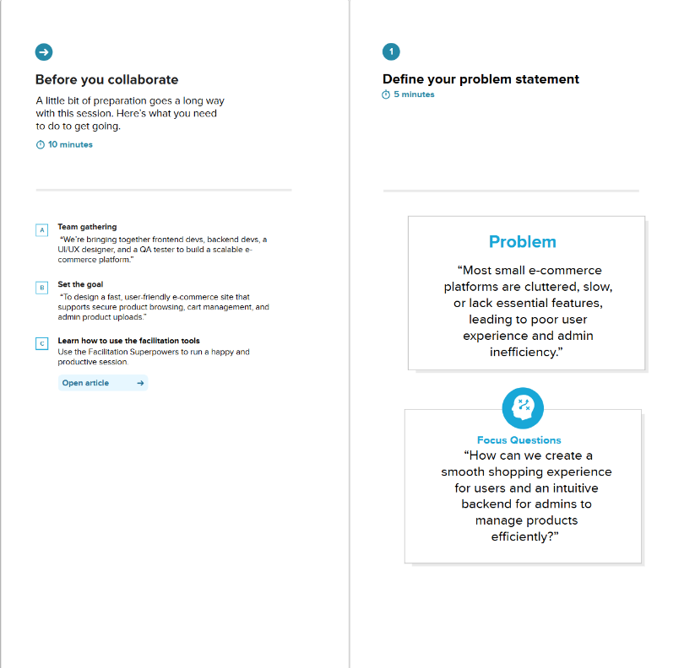

**Step 2: Brainstorm, Idea Listing and Grouping**

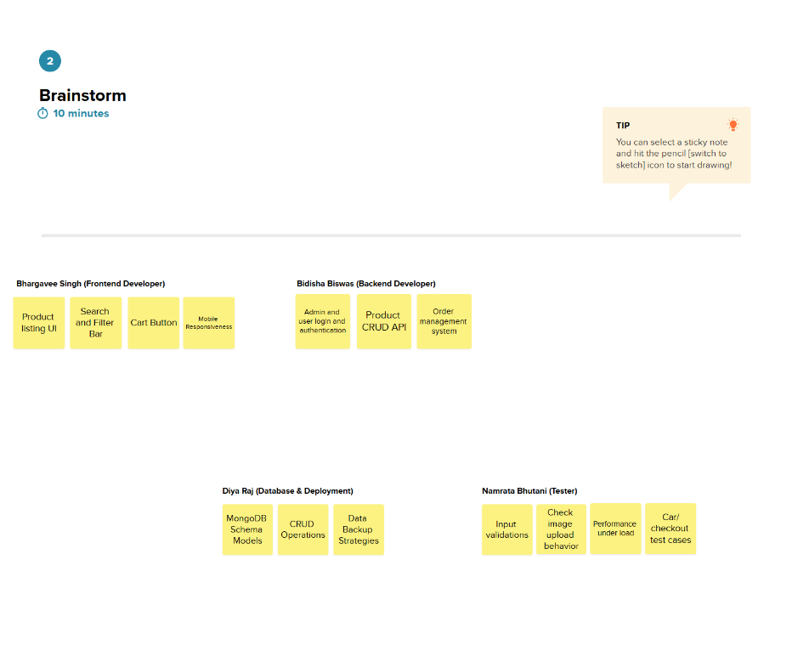

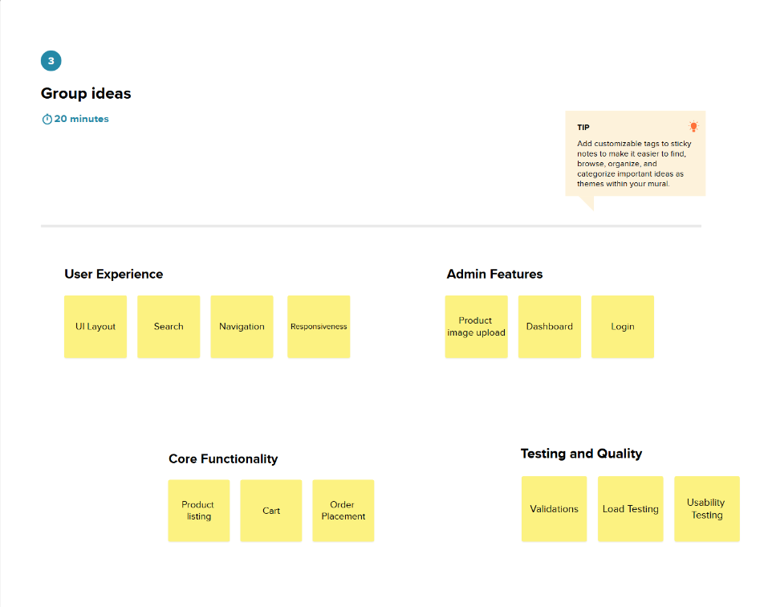

**Step 3: Idea Prioritization**

